**Project Documentation**

**COOKBOOK – THE VIRTUAL KITCHEN**

**1. INTRODUCTION:**

• **Project Title:  COOKBOOK – THE VIRTUAL KITCHEN**

• **Team ID :** 2DC08CB040868CBA07140BBEB9BC4633

• **Team Leader:** ASHA.A – 202400940@sigc.edu

• **Team Members:**

* Aishwarya V – 202400774@sigc.edu
* Anugraha SS – 202400939@sigc.edu
* Ashika T – 202400923@sigc.edu

**2. PROJECT OVERVIEW:**

* **Purpose:** Cookbook – The Virtual Kitchen is an interactive recipe platform that provides users with a variety of cooking options, including vegetarian, non-vegetarian, breakfast, and starters.
  + Each recipe includes ingredient details and a YouTube video tutorial for step-by-step guidance. The platform aims to make cooking accessible and enjoyable for people of all skill levels.
* **Features:**
  + Recipe collection (Veg, Non-Veg, Breakfast, Starter)
  + Ingredient details for each recipe
  + YouTube video tutorial integration
  + Responsive design (desktop and mobile accessibility)
  + Easy navigation with a simple UI
  + **User-Friendly Interface:** Sleek, easy-to-use design tailored for all skill levels, making it perfect for beginners or seasoned chefs.

**3. ARCHITECTURE:**

* **Frontend:**  
  The frontend of **Cookbook – The Virtual Kitchen** is built using **HTML, CSS, and JavaScript**, with **React.js** for creating dynamic and interactive UI components. React enables a seamless user experience by updating only the parts of the page that change, making the application faster and more responsive.
* **Backend:**  
  This project does not require a backend server as it is a static web application. However, if extended in the future, a **Node.js** and **Express.js** setup could be used to handle user interactions, dynamic data, and API endpoints. **Node.js** is a runtime environment for executing JavaScript server-side, and **Express.js** is a web framework that simplifies routing and middleware management.
* **Database:**  
  Since **Cookbook – The Virtual Kitchen** is a static website with no user login or data storage, it does not require a database in its current state. However, for future features like user-submitted recipes, reviews, or personalized recipe suggestions, a **MongoDB** database could be integrated. **MongoDB** would store user data, project information, recipe details, and any interactions (such as reviews or favorites), while enabling efficient querying and scalability.

**4. SETUP INSTRUCTIONS:**

* **Prerequisites:**
  + **Node.js:** A JavaScript runtime used for server-side development (if extending the project to include backend features).
  + **MongoDB:** No database required for this static website, but can be used if integrating dynamic features like user accounts and data storage.
  + **Git:** Version control system to clone the repository and manage code.
  + **React.js:** A JavaScript library for building user interfaces, used to make the frontend dynamic.
  + **Express.js:** A minimal and flexible Node.js web application framework (used if you plan to extend the project to a backend).
  + **Mongoose:** An ODM (Object Data Modeling) library for MongoDB and Node.js, useful when connecting a MongoDB database to the backend.
  + **Visual Studio Code:** A powerful code editor for development, with support for various extensions (like JavaScript, React, etc.).
* **Installation Steps:**

1. Clone the repository: ***git clone [repository-link]***

2. Navigate to the ***client*** directory and install the frontend dependencies:  
***cd client  
npm install***

3. If adding backend functionality, navigate to the ***server*** directory and install the server dependencies:  
***cd ../server  
npm install***

4.Run the project:

**Frontend:**  
Navigate to the ***client*** directory and run: ***npm start***

**Backend (Optional):**  
If using backend functionality, run the server from the server directory: ***npm*** ***start***

5.Access the Application:  
Open your browser and visit:  
***http://localhost:3000*** (for the frontend)  
(Note: If a backend is implemented, use the appropriate port for the server).

**5. Folder Structure:**

SB-Works/

│

├── client/ # React frontend

│ ├── components/ # Contains reusable UI components

│ ├── pages/ # Contains different pages of the app

│ ├── public/ # Static assets like images and favicon

│ ├── src/ # Source files

│ │ ├── components/ # Reusable components for the frontend

│ │ ├── pages/ # Page components (like Home, Recipe pages, etc.)

│ │ ├── styles/ # CSS or styling files for the frontend

│ │ ├── App.js # Main app component

│ │ ├── App.css # Main styles for the app

│ │ └── index.js # Entry point for React app

│ └── package.json # Dependencies and project scripts

│

├── server/ # Node.js backend

│ ├── routes/ # Contains route files to handle requests

│ ├── models/ # Contains models to interact with databases

│ ├── controllers/ # Logic for handling requests and responses

│ └── server.js # Entry point for Node.js backend

│

└── .gitignore # Git ignore file to avoid unwanted files in version control

**6. RUNNING THE APPLICATION:**

To run the application, follow these steps for both the **Frontend** (React) and **Backend** (Node.js).

**Frontend:**

1. Open a terminal or command prompt.
2. Navigate to the client folder:
3. cd client
4. Install dependencies:
5. npm install
6. Start the React development server:
7. npm start

The React app will now be running at <http://localhost:3000>.

**Backend:**

1. Open a separate terminal window.
2. Navigate to the server folder:
3. cd server
4. Install dependencies:
5. npm install
6. Start the Node.js server:
7. npm start

The backend server will now be running.

**7. AUTHENTICATION:**

The application uses **JWT (JSON Web Token)** for secure user authentication. This ensures that user data and sessions are protected and managed effectively.

* **JWT-Based Authentication**
* **Login**: When a user successfully logs in with their credentials (email and password), the backend generates a **JWT token** that contains the user's identification and a set of claims.
* **Token Generation**: Once the user logs in, a token is generated and sent to the frontend, which stores it in local storage or as a cookie for subsequent requests.
* **Token Structure**: The token typically contains:
  + Header: Information about how the token is signed.
  + Payload: User-related information (like user ID) and any custom claims.
  + Signature: Used to verify the authenticity of the token.
* **Token Expiration**: The JWT token has an expiration time, after which the user needs to reauthenticate.
* **Middleware for Protected Routes**
* **Private Routes Protection**: To protect sensitive or private endpoints, middleware is used to verify that the incoming request contains a valid JWT token.
* **How It Works**:
  1. The middleware checks the Authorization header of the incoming request.
  2. If the token is valid and not expired, the request proceeds to the requested resource.
  3. If the token is invalid or missing, the middleware returns a **401 Unauthorized** status.
* **Example of Middleware** (Node.js):

const jwt = require('jsonwebtoken');

const authenticate = (req, res, next) => {

const token = req.header('Authorization');

if (!token) {

return res.status(401).json({ message: 'Access denied. No token provided.' });

}

try {

const decoded = jwt.verify(token, process.env.JWT_SECRET);

req.user = decoded; // Attach the user information to the request

next(); // Proceed to the next middleware or route

} catch (error) {

res.status(400).json({ message: 'Invalid token.' });

}

};

module.exports = authenticate;

**Usage in Protected Routes**

* For any protected route, you need to add the authenticate middleware:

const authenticate = require('./middleware/authenticate');

app.get('/api/protected-resource', authenticate, (req, res) => {

res.status(200).json({ message: 'You have access to this resource.' });

});

**8.USER INTERFACE:**

This webpage is a recipe web application built with React (as seen from the browser tab “React App” and the localhost URL).

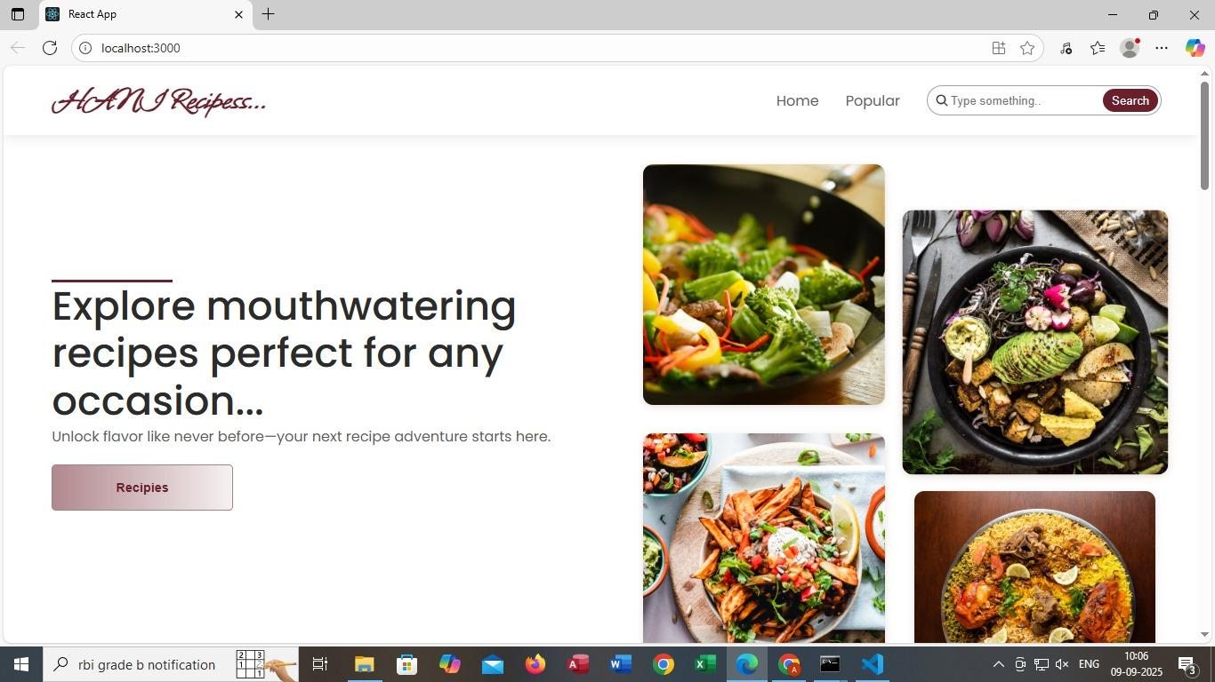

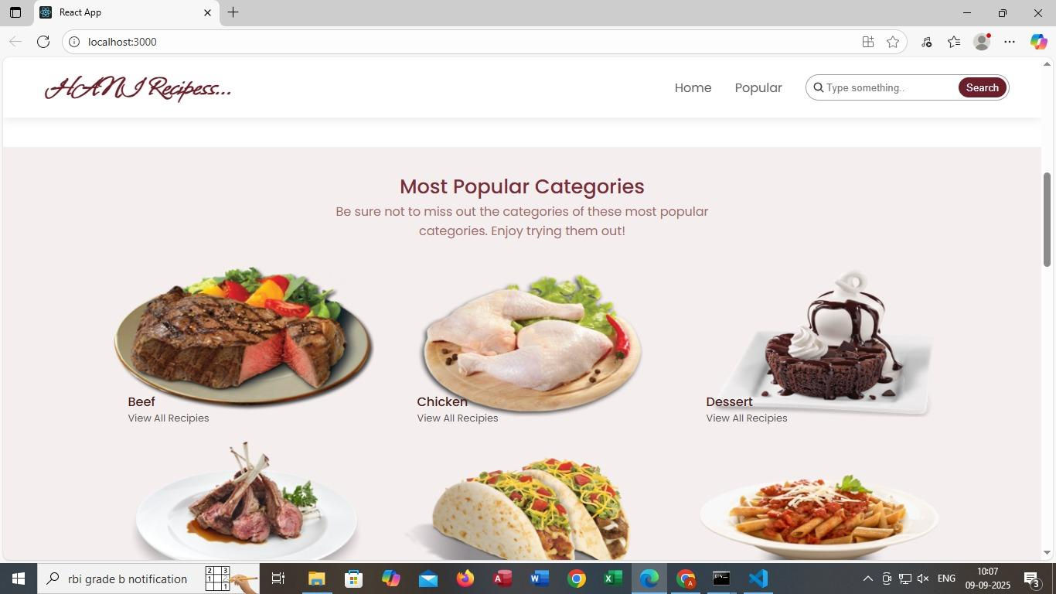

This page is for "H&M Recipes..." (though it seems like a typo and might be meant to be "Homemade Recipes"). It's a webpage showing "Most Popular Categories" of recipes. You've got Beef, Chicken, and Dessert categories displayed with images and a "View All Recipes" option for each. There's also a partial view of three more categories at the bottom: Lamb Chops, Tacos, and Pasta. The page has navigation options like Home, Popular, and a search bar. 😋

On this page, the Beef category shows an image of a grilled beef steak served with veggies on a plate. You can click "View All Recipes" under Beef to explore more beef-based recipes. Beef is one of the most popular categories highlighted on this Homemade Recipes webpage. 🍔🔥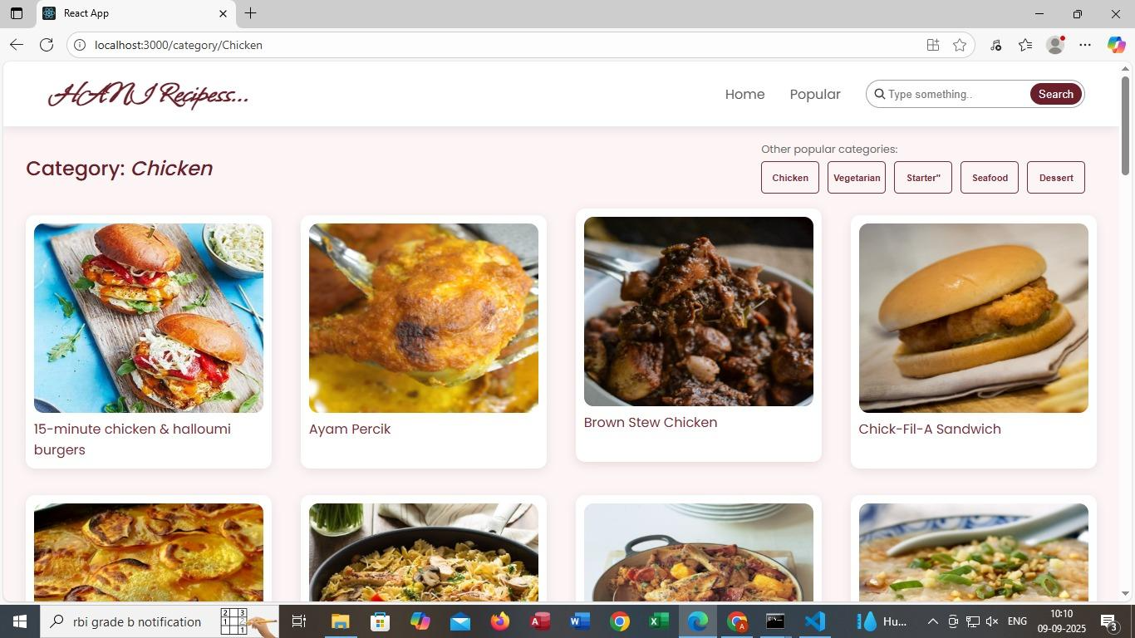

**Here’s a breakdown of the page:**

**Header Section (Top Bar):**

* Logo: "**HANI Recipes**..." styled in cursive.
* Navigation menu with links like Home and Popular.
* A search bar with placeholder text “Type something...” and a "Search" button to find recipes.

**Hero Section (Main Highlight):**

* A large heading: “Explore mouthwatering recipes perfect for any occasion...”
* A subheading: “Unlock flavour like never before—your next recipe adventure starts here.”
* A button labelled “Recipes” to guide users toward the recipe collection.

**OUR SIGNATURE RECIPES:**

**🧁 BATTERNBERG CAKE( PINK & YELLOW PATTERN)**

* Battenberg Cake is a classic British sponge cake known for its distinctive pink and yellow checkered pattern. Traditionally, it's made by baking two colored sponge cakes separately, then slicing and assembling them into a checkerboard layout. The pieces are glued together with apricot jam and wrapped in a smooth layer of marzipan, giving it a sweet almond finish.
* It’s believed to have been created in 1884 to celebrate the marriage of Princess Victoria (Queen Victoria’s granddaughter) to Prince Louis of Battenberg, hence the name. The cake quickly became a royal favorite and remains a charming centerpiece at British tea tables today.
* The Battenberg cake—an absolute British classic! 🇬🇧 I found some delightful images for you, and they should be showing up now.
* This charming sponge cake is known for its distinctive checkerboard pattern, typically pink and yellow squares, wrapped in a layer of marzipan. It’s held together with apricot jam and often served at tea time. The visual appeal is half the fun, but the almond flavor and soft texture make it a treat worth savoring.

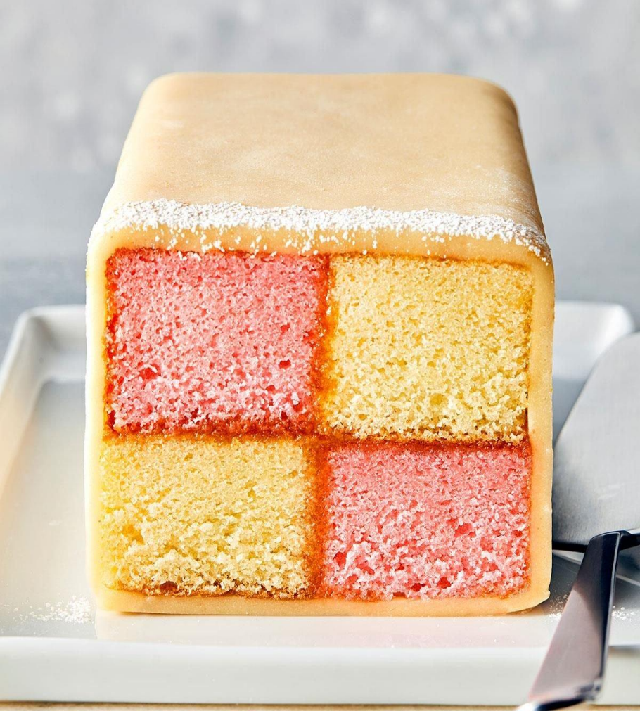

**INGREDIENTS:**

* 175g very soft butter
* 175g golden caster sugar
* 140g self-raising flour
* 50g ground almonds
* ½ tsp baking powder
* 3 medium eggs
* ½ tsp vanilla extract
* ¼ tsp almond extract
* Pink food colouring
* 200g apricot jam
* 2 blocks white marzipan
* Icing sugar (for dusting)

**🥣 INSTRUCTIONS:**

* Preheat Oven Heat oven to 180°C (160°C fan) or gas mark 4. Line a 20cm square tin with parchment paper, crossing two strips for easy removal.

* **Make the Almond Sponge** In a large bowl, beat butter, sugar, flour, ground almonds, baking powder, eggs, vanilla, and almond extract until smooth. Pour into the tin and bake for 25–30 minutes. Cool on a wire rack.

* **Make the Pink Sponge** Repeat the sponge-making process, omitting almond extract and adding pink food colouring. Bake and cool as above.

* **Cut and Assemble** Trim edges of both sponges. Measure the height and cut each sponge into four equal strips. Arrange two pink and two almond strips in a checkerboard pattern, using warmed and sieved apricot jam to stick them together.

* **Wrap in Marzipan** Roll out marzipan to 0.5cm thickness. Brush with jam and place the sponge checkerboard on top. Wrap marzipan around the cake, sealing the edges and trimming excess. Crimp edges with fingers or a fork.

* **Serve or Store** Mark slices with a fork if desired. Store in an airtight container for up to 3 days or freeze for up to a month.

**🍛 MATAR PANEER (PEAS & COTTAGE CHEESE CURRY)**

 A classic North Indian vegetarian dish made with soft paneer cubes and green peas simmered in a spiced tomato-onion gravy. Comforting, flavorful, and perfect with roti or rice.

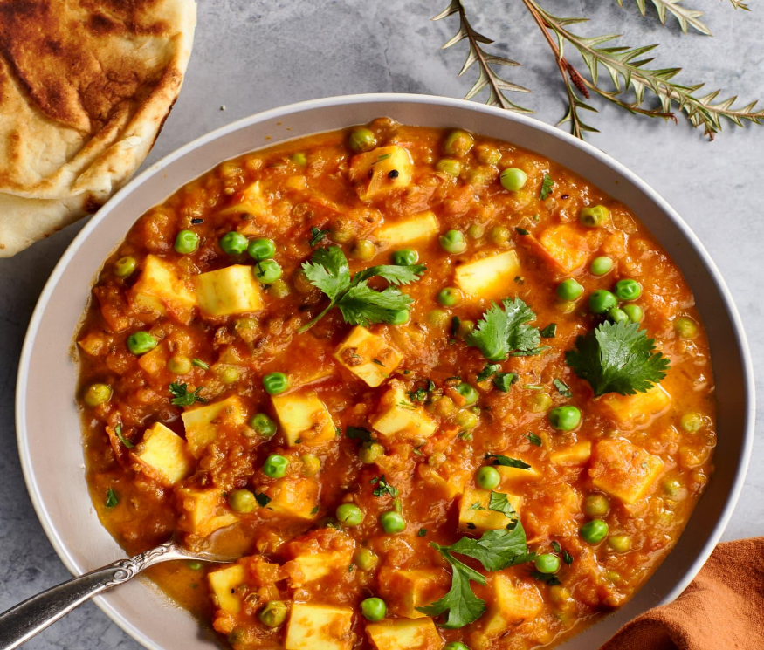

**🧾 Ingredients:**

* 250g paneer (cubed)
* 1 cup green peas (fresh or frozen)
* 2 medium onions (finely chopped)
* 1 cup tomato purée
* 1 tsp ginger-garlic paste
* ½ tsp turmeric powder
* 1 tsp cumin seeds
* 1 tsp coriander powder
* ½ tsp garam masala
* Salt to taste
* 2 tbsp oil or ghee
* Fresh coriander leaves (for garnish)

**👨‍🍳 Instructions:**

1. **Sauté spices**: Heat oil in a pan. Add cumin seeds and let them splutter. Add onions and sauté until golden.
2. **Cook the base**: Add ginger-garlic paste, tomato purée, turmeric, coriander powder, and salt. Cook until oil separates.
3. **Add peas & paneer**: Stir in green peas and paneer cubes. Add a splash of water and simmer for 10 minutes.
4. **Finish**: Sprinkle garam masala and garnish with chopped coriander. Serve hot.

**9.KNOWN ISSUES:**

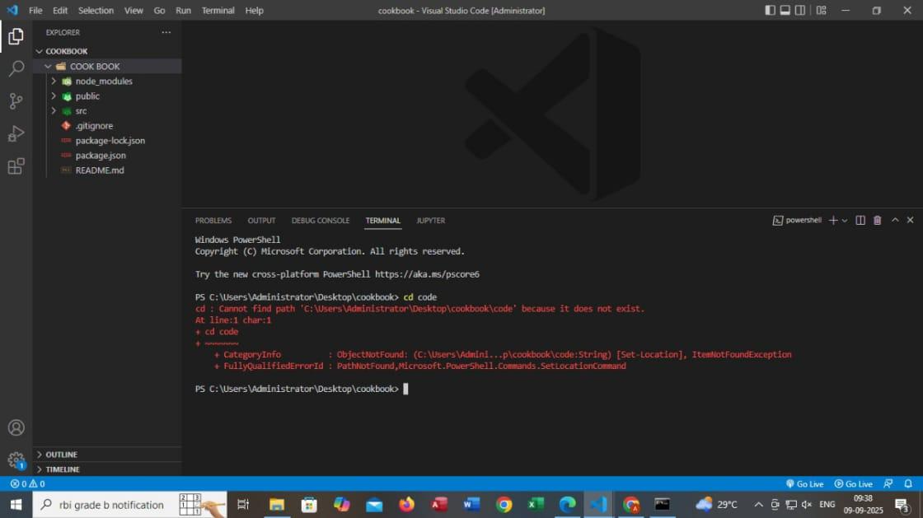

The error in this picture is a "PathNotFound" error in PowerShell.

Error message: cd : Cannot find path 'C:\Users\Administrator\Desktop\cookbook\code' because it does not exist.

 Cause: The directory code does not exist within the cookbook directory.

CategoryInfo: ObjectNotFound

FullyQualifiedErrorId: PathNotFound,Microsoft.PowerShell.Commands.SetLocationCommand.

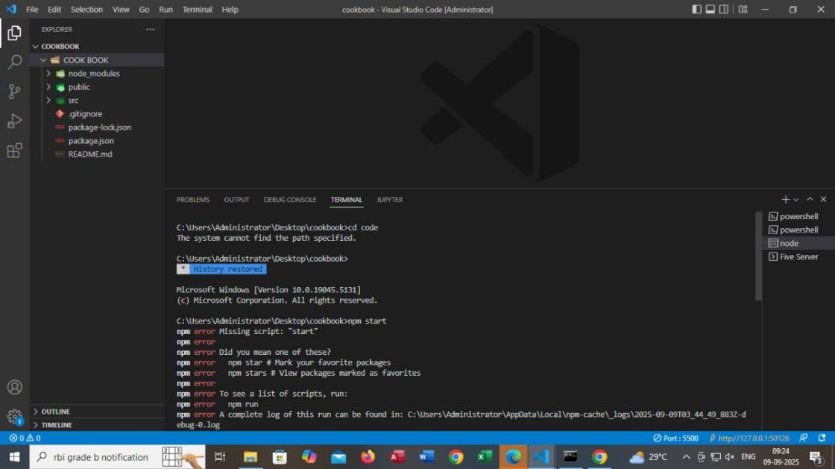

The error in the picture is due to running npm start in a directory where there's no script named "start" defined in package.json.

npm is suggesting alternatives like:

- npm star to mark favorite packages

- npm stars to view packages marked as favorites

**10. LINK TO A DEMO SHOWCASING:**

* <https://drive.google.com/file/d/1H35nUerdu65UjTNtbnxVEU3nb6->







**11. DRIVE LINK TO A WEBPAGE CODE:**

* <https://drive.google.com/drive/folders/1tLFeB0hR260DEq8j6gV_fYdazDPiGqYN?usp=drive_link>

**12. FUTURE ENHANCEMENTS:**

* **Add a Search Bar to Find Recipes Quickly**
* **Description:** Implement a search bar that allows users to quickly search for recipes by name, ingredients, or categories. This will make it easier for users to find specific recipes without having to navigate through multiple pages.
* **Possible Features:**
  + Autocomplete suggestions while typing.
  + Filters based on categories or dietary preferences (e.g., vegetarian, gluten-free).
* **Enable User-Submitted Recipes**
* **Description:** Allow users to submit their own recipes to the platform. This will create a community-driven database of recipes where users can share their own cooking ideas.
* **Possible Features:**
  + A form to submit recipes with ingredients, steps, and images.
  + Option to edit or delete submitted recipes.
  + Option for recipe moderation to ensure quality control.
* **Add a Rating and Review System**
* **Description:** Implement a rating system for each recipe, where users can rate recipes on a scale (e.g., 1 to 5 stars) and leave comments or reviews. This will help other users discover the best recipes and provide valuable feedback for improvements.
* **Possible Features:**
  + Rating system based on user feedback.
  + Review section for each recipe.
  + Ability to sort recipes by rating.
* **Convert into a Mobile App Version**
* **Description:** Convert the web application into a mobile app to reach a wider audience and provide a more convenient user experience on smartphones and tablets.
* **Possible Features:**
  + Native app development for iOS and Android using frameworks like React Native.
  + Offline mode to access saved recipes without internet connection.
  + Push notifications for new recipes or updates.